Bučovice Blind Football Cup 2018

Final Report
We organised the 6th Bučovice Blind Football Cup during the weekend from 30th June to 1st July. For the second time, the players of Worcester Blind Football Club from England became the champions as they beat the Spanish team from Madrid during the final game. The fans were happy to see the home team on the 3rd place. Avoy MU Brno finally reached the medals after six years of the tournament.

We thank all the fans, friends, partners and sponsors who help us and support the tournament.

The tournament's organizers: Avoy MU Brno, z. s.
The tournament's partners and sponsors: Avast foundation, Seznam.cz, Masaryk University, Světluška – Nadační fond Českého rozhlasu, Southmoravian region, Ministry of Education, Youth, and Sports of the Czech Republic, The Football Association of the Czech Republic, Leontinka foundation, Charta 77 foundation, Penzion U Matulů, ZŠ Školní 710 in Bučovice, SportObchod.cz

The final report contains:
- Article on tournament (including results, goals, yellow/red cards)
- Final standings of the teams
- The best players of the tournament
- The list of shooters
- Participants' feedback
- Photographs and video
- The list of partners and sponsors

1. Article on tournament
During the weekend from 30th June to 1st July we organised the 6th annual international tournament Bučovice Blind Football Cup 2018. The ceremonial kick-off was performed by a valuable person. Matěj Plch was the main initiator of the activities heading to the establishment of blind football in the Czech Republic before 2008 and only thanks to his endless will and aspiration our club in Brno came into existence. Matěj himself was our team leader for years and we are glad he didn’t forget about us and accepted our invitation to the event.
There were eight European teams, each of them from a different country. For the first time we invited the Spanish squad Santagadea ONCE Madrid and the Austrian team Östereichische Behindersport Verband from Vienna. The title was defended by its last year´s winner, Five-a-side Anderlecht from Belgium. Another team aspiring to win the tournament was Worcester Blind Football Club from England. Apart from these teams and the home squad Avoy MU Brno, friends from Greece (Asamea Keravnos), Poland (Tyniecka Kraków) and Germany (FC St. Pauli Hamburg) came as well.
We kept the tournament system from the previous years, so there were again matches in two groups and then an exciting knock-out part. We offered an innovation, an application called Speekie which enabled spectators to listen to a professional commentary of all the matches on their own mobile phones. Moreover, we did not forget about the fans of blind football who were not able to participate in our tournament. We offered them a possibility to follow a live video stream of all the matches together with the professional commentary or to look at online statistics of the tournament in our application BBFC Timer.
For the second time, the players of Worcester Blind Football Club from England became the champions as they beat the Spanish team from Madrid during the final game. The fans were happy to see the home team on the 3rd place. Avoy MU Brno finally reached the medals after six years of the tournament.

Group A
The main leader of group A, the Spanish team from Madrid, didn’t lose a single point during all the matches. Their goalkeeper received only one goal during the opening game against Asamea Keravnos from Athens. The young 13-year-old Nico Rother scored the equalizer but the Spanish players replied very quickly and after a minute took back their control over the match as the oldest player from Madrid, Vicente Aguilar Carmona (48 years old), scored another goal. At the end of the game, the Spanish footballers added one more goal and celebrated their 3-1 victory.
The home team also obtained the three compulsory points but it was not easy at all. Jan Mrázek managed the first goal against the newcomers from Vienna very quickly. But mainly during the second half of the game the home team players were not sure of the result and the victory 1-0 was brought especially by the brilliant saves of the goalkeeper Tomáš Bukovský. The Spanish team then managed an easy victory against the team from Vienna and the next game was the key one to decide about the second place within the group A ensuring a “ticket” to the semifinals. The match between Avoy MU Brno and Asamea Keravnos ended up with a goalless draw 0-0. The home team players had more chances to score a goal but they only hit the posts and bars or struggled unsuccessfully with the well-prepared Greek goalkeeper.
In their last game of group A on Saturday, Avoy MU Brno tried to get at least one point against the Spanish team who was sure to go to the semifinals. Victor Acevedo opened the score in the 9th minute. Keryn Seal was the most dangerous home team player but only hit the post twice. An exciting match full of physical confrontations didn’t allow the spectators to have a rest. At the end of the first half, François Carcouët had to give the red card to Vicente Aguilar who failed to respect the previous decision of the referee and attacked him physically. The Czechs were not able to take advantage of the powerplay and right after it had finished, Sergio Alamar Garcia, later elected the best striker of the tournament, scored a goal. Avoy MU Brno lost the game 0-2 and needed the help of the Austrian team to go to the semifinals.
In the first game of Sunday morning, ÖSBV Vienna played against Asamea Keravnos, the main rival of the home team hoping for the free slot in the first semifinal game. Adriano Bezhani opened the score and helped the Greek “lightnings” to lead the game. At the end of the first half there was a big surprise for everyone when Mustafa Hösgören managed to score an equalizer. The team from Athens was not able to overcome the excellent defence of the Vienna team and obtained only one point. Because of this loss the Vienna team allowed Avoy MU Brno to step into the semifinals!

Overview of Group A matches
When | Teams | Score | Goals scored | Yellow/red cards
Saturday 9:00 | Santagadea ONCE  Madrid – Asamea  Keravnos | 3:1 (1:0) | Madrid: Sanchez Lopez 2, Aguilar Carmona;  Keravnos: Rother
Saturday 11:00 | Avoy MU Brno – ÖBSV Vienna | 1:0 (1:0) | Brno: Mrázek
Saturday 13:00 | Santagadea ONCE  Madrid – ÖBSV Vienna | 4:0 (1:0) | Madrid: Aguilar Carmona 2, Sanchez Lopez, Alamar Garcia
Saturday 15:00 | Avoy MU Brno – Asamea Keravnos | 0:0 (0:0)
Saturday 17:00 | Santagadea ONCE  Madrid – Avoy MU Brno | 2:0 (1:0) | Madrid: Acevedo Fernandez, Alamar Garcia | Madrid: Aguilar Carmona (ČK); Brno: Seal (ŽK)
Sunday 9:00 | Asamea Keravnos – ÖBSV Vienna | 1:1 (1:1) | Keravnos: Bezhani;  Vienna: Hösgören

Group A table
# | Team | Wins | Draws | Losses | Score | Points
1. | Santagadea ONCE Madrid | 3 | 0 | 0 | 9:1 | 9
2. | Avoy MU Brno | 1 | 1 | 1 | 1:2 | 4
3. | Asamea Keravnos | 0 | 2 | 1 | 2:4 | 2
4. | ÖBSV Vienna | 0 | 1 | 2 | 1:6 | 1

Group B
The situation in group B was also complicated from the very beginning. All the teams relied on their brilliant defence so the first goal was scored in the 4th match of this group! The games of Anderlecht vs. St. Pauli, Worcester vs. Kraków, and Anderlecht vs. Kraków ended up without a goal.
Worcester then secured the 1st place in group B and a slot in the semifinals with two victories.At first, the team from England beat St. Pauli (1-0) and then defeated Anderlecht (2-1). The German goalkeeper capitulated to a last minute goal at the end of the first half as Roy Turnham was able to control the ball after the goal clearance of Dylan Malpas. Roy then turned around with the ball quickly and shot through Swen Gronau in the goal of St. Pauli. The German players had the second half to equalize but finally they were not able to score a goal even in their second match in the tournament. The following game of Worcester and Anderlecht was quickly started in the 2nd minute by the opening goal by Christoff Eilers from Belgium who was able to orientate himself the best in the confusing situation of the opponents’ penalty area and was the quickest to find the ball there. The players of Worcester managed to get the score on their side as Robin Williams shot two goals after two almost identical actions. In both cases he bewildered three defenders with quick dribbling and getting in front of the goalkeeper, he succeeded. The second half of the game was an exciting performance but no other goal was scored. The Belgian team paid a lot for their loss 1-2 as their chance to go to the semifinals and to reclaim the cup died out.
On Sunday morning, the match for the second place of group B and the last free slot in the semifinals took place. FC St. Pauli played against Tyniecka Kraków who were in a more advantageous situation. The Polish team needed only a single point to finish second in group B. However, the Germans fought very sharply and Paul Ruge shot a goal in the 6th minute. The next shooting chances of St. Pauli ended up without success. The second half of the game was a bit boring. The players of Kraków were not able to prepare any chance, the German players concentrated only on their defence. It was a big shock for the audience when Robert Mkrtchyan from Kraków shot a goal two minutes before the end of the game. He was forceful enough inside the penalty area so his last minute goal launched the Polish team into the semifinals whilst the German players could hardly hide their tears.

Penalty shootout for the 3rd place
It was the penalty shootout with Five-a-side Anderlecht which brought the players of FC St. Pauli another reason to be out of tune. After three matches in group B, both teams had the same amount of points, the same score and the same joint match. So the necessary shootout for the 3rd and 4th place in group B was performed during the break between the two semifinal games. The first three shooters selected from each team were not successful. During the 4th round both Christoff Eilers and Serdal Celebi shot the goals. The decision was made in the 5th run as Aaron Aponja Fall from Anderlecht suceeded whereas Michael Preul from St. Pauli didn’t score and became the sad hero of the shootout. Not only didn’t St. Pauli reach the semifinals after the last minute lucky goal by Kraków, but the lost penalty shootout also sent the German team to play for the 7th place whilst Anderlecht looked forward to the match for the 5th place.

Overview of Group B matches
When | Teams | Score | Goals scored | Yellow/red cards
Saturday 10:00 | Five-a-side Anderlecht – FC St. Pauli | 0:0 (0:0)
Saturday 12:00 | Worcester BFC –  Tyniecka NWP Kraków | 0:0 (0:0)
Saturday 14:00 | Five-a-side Anderlecht – Tyniecka NWP Kraków | 0:0 (0:0)
Saturday 16:00 | Worcester BFC – FC St. Pauli | 1:0 (1:0) | Worcester: Turnham
Saturday 18:00 | Five-a-side Anderlecht – Worcester BFC | 1:2 (1:2) | Anderlecht: Eilers; Worcester: Williams 2 | Anderlecht: Eilers (ŽK)
Sunday 10:00 | FC St. Pauli –  Tyniecka NWP Kraków | 1:1 (1:0) | St. Pauli: Ruge;  Kraków: Mkrtchyan

Group B table
# | Team | Wins | Draws | Losses | Score | Points
1. | Worcester BFC | 2 | 1 | 0 | 3:1 | 7
2. | Tyniecka NWP Kraków | 0 | 3 | 0 | 1:1 | 3
3. | Five-a-side Anderlecht | 0 | 2 | 1 | 1:2 | 2
4. | FC St. Pauli | 0 | 2 | 1 | 1:2 | 2

Knock-out games

Semifinals
Both semifinals became quite clear issues. The home team was not able to defend themselves against the two main offensive stars of Worcester, Roy Turnham and Robin Williams. These players were extra quick in dribbling but they also helped their teammates to defend. The players of Brno were able to face up the offensive pressure for the first twelve minutes before Roy Turnham celebrated his first goal. At the end of the first half he added another one to put his team into a secure position. After half-time, Jan Mrázek had two good chances to score but he didn't succeed, so the last goal to set up the score 3-0 came at the end of the game after the shot of Robin Williams who sent his team to the final match for certain.
When entering the semifinals, the Spanish team missed Vincente Aguilar who had been penalised. That was the reason for the weaker offensive performance of Madrid, especially as the Polish players defended as much as they were able to. Sergio Alamar Garcia became the key person of the match as he opened the score at the end of the first half. Even after half-time the players of Kraków had to concentrate mostly on the defence because the attacks of Madrid were very dangerous. Robert Mkrtchyan, the Polish offender, was not able to overcome the predominant Spanish defence, so Sergio Garcia concluded the match with another goal in the 35th minute. The game ended up with the score of 2-0 for Madrid.

Ranking matches
The team of St. Pauli won the match for the 7th place quite persuasively as ÖSBV Viennamissed their defender Alphonse Lekanga. The German captain Rasmus Narjes showed off with a hattrick and managed to get the victory 4-0 and the final 7th place for his team. The match for the 5th place brought Asamea Keravnos against Five-a-side Anderlecht and was more balanced. Agoal by Adriano Bezhani in the 27th minute decided about the victory 1-0for the Greek team.
The next game for the 3rd place made the home team very happy. It was a very well-balanced match against Kraków. The players of both teams were tired so they didn’t show off much when attacking the goal. In the first half, the Brno team quickly commited 4 team fouls so the players of Kraków performed three 8-metres penalties. They didn’t succeed thanks to the brilliant saves of Tomáš Bukovský. It was the home team who tried more to attack the goal of its rival in the second half, but the score stayed the same and a penalty shootout had to decide about the winner. The first two players of Avoy MU Brno were successful, both Michal Petráš and Jan Mrázek striked goals. On the other hand, Adrian Sloninka didn’t score and when the best player of Kraków, Robert Mkrtchyan, didn’t succeed either, the home team’s celebrations could start. The players of Brno had to wait for six years to be finally awarded medals!
The final match became a really extraordinary one. The pace of the game was much faster than during the game for the 3rd place. Each team had players who are members of the Spanish, or English national team. Worcester players were more skilled when finishing their combinations and that was the ultimate reason for their victory. While both the offensive stars of the English team managed to score a goal, Sergio Alamar Garcia was not able to overcome the well compressed defence of the opponent. At the end of the first half, Roy Turnham hid his shot behind a defender and scored. Robin Williams finalized the score 2-0 by adding another goal at the end of the match. Dribbling, he overcame the two-person defence and striked the ball, rolling it on the ground in the opposite direction than the Spanish goalkeeper moved. The players of Madrid proved their quality and became an equal opponent to the overall winner of the finals, so the spectators had the opportunity to watch top-level blind football.
When | Teams | Score | Goals scored | Yellow/red cards
Sunday 11:00 1st semifinal | Avoy MU Brno – Worcester BFC | 0:3 (0:2) | Worcester: Turnham 2, Williams
Sunday 12:00 2nd semifinal | Santagadea ONCE  Madrid – Tyniecka NWP Kraków | 2:0 (1:0) | Madrid: Alamar Garcia 2
Sunday 13:00 for the 7th place | ÖBSV Vienna – FC St. Pauli | 0:4 (0:1) | St. Pauli: Narjes 3, Celebi
Sunday 14:00 for the 5th place | Asamea Keravnos –  Five-a-side Anderlecht | 1:0 (0:0) | Keravnos: Bezhani | Brno: Seal (ŽK), Keravnos:  Feimoglou (ŽK)
Sunday 15:00 for the 3rd place | Avoy MU Brno – Tyniecka NWP Kraków | 1:0 (0:0, 0:0) | Brno: Petráš
Sunday 16:00 final | Worcester BFC –  Santagadea ONCE Madrid | 2:0 (1:0) | Worcester: Turnham, Williams

2. Final ranking of the participating teams
1. Worcester BFC (Great Britain)
2. Santagadea ONCE Madrid (Spain)
3. Avoy MU Brno (Czech Republic)
4. Tyniecka NWP Kraków (Poland)
5. Asamea Keravnos (Greece)
6. Five-a-side Anderlecht (Belgium)
7. FC St. Pauli (Germany)
8. ÖBSV Vienna (Austria)

3. Best players
Best goalie: Dylan Malpas (Worcester BFC)
Best defender: Keryn Seal (Avoy MU Brno)
Best forward: Sergio Alamar Garcia (Santagadea ONCE Madrid)
Fair-play award: Nico Rother (Asamea Keravnos)
Fans award: FC St. Pauli

4. List of shooters
# | Player | Team | Goals
1.–3. | Roy Turnham | Worcester BFC | 4
1.–3. | Robin Williams | Worcester BFC | 4
1.–3. | Sergio Alamar Garcia | Santagadea ONCE Madrid | 4
4.–6. | Miguel Angel Sanchez Lopez | Santagadea ONCE Madrid | 3
4.–6. | Rasmus Narjes | FC St. Pauli | 3
4.–6. | Vicente Aguilar Carmona | Santagadea ONCE Madrid | 3
7. | Adriano Bezhani | Asamea Keravnos | 2
8.–16. | Paul Ruge | FC St. Pauli | 1
8.–16. | Christoff Eilers | Five-a-side Anderlecht | 1
8.–16. | Jan Mrázek | Avoy MU Brno | 1
8.–16. | Michal Petráš | Avoy MU Brno | 1
8.–16. | Nico Rother | Asamea Keravnos | 1
8.–16. | Serdal Celebi | FC St. Pauli | 1
8.–16. | Robert Mkrtchyan | Tyniecka NWP Kraków | 1
8.–16. | Mustafa Hösgören | ÖBSV Vienna | 1
8.–16. | Victor Manuel Acevedo Fernandez | Santagadea ONCE Madrid | 1

5. Participants' feedback
Dylan Malpas (goalkeeper of the English national team, recently awarded the best goalkeeper prize): A massive thank you to Jitka Graclíková and Tomáš Bukovský for hosting the 6th Bučovice Blind Football Tournament. By far the best club championships in Europe. Fantastic to play against such strong competitive opposition as well as having a great laugh off the pitch with incredible people who share the same passion for Blind Football as us. Couldn't be any prouder of our lads beating a very strong and talented Bnfit Once Madrid 2-0 in the final by playing some great football. None of this would of been possible without the organisation of Dan James, so a huge thank you for giving us all the opportunity to play and be part of this tournament. Finally a great honour personally to be named the best goalkeeper of this tournament, an achievement that I am very proud off. Thank you once again for having us all, for me events like this really puts the love back in playing blind football!!!!!!
Five-a-side Anderlecht team: Thanks a million all the people who worked for the success of this tournament which, once again, was organized by master hand : Avoy MU Brno, Jitka Graclíková and Tomáš Bukovský ! Many thanks also to the volunteers, supervisors, canteen managers, photographers and referees! As every year, it was a real pleasure to participate in this high-level competition where the good atmosphere is always there! No words enough to thank you Jitka and Buky! Brussels 5-a-side Anderlecht is so happy to join that wonderful tournament!
Kevin Vanderborght (player of the Belgian national football team, Anderlecht’s team forward): Exactly for such moments we love the blind football! Thanks to Jitka Graclíková and the whole team, without you this great tournament would not exist!
Gerson Countinho (ICB Bahia team’s coach, Brazil): Congratulations to everyone. It's a huge tournament and very well organized.
Darren Harris (player of the British national football team, Worcester team’s player): You truly amaze me once again. How can you all be so beautiful? Thanks for another brilliant event, tell me where you want me to post my raving testimonial if it will help continue this superb tournament. I love you all more than ever. Do take care. You guys give so much, I hope you get what you want in return.
Martin Demonte (coach of the Argentinian national team): Congratulations!!! Very good work!!
Luis Antonio Castaneda Tenjo: Congratulations to Jitka Graclíková because she’s one who supports so great a sport called Blind Football in the world. I send all greetings from Colombia.
Mateusz Krzyszkowski (player of the Polish national team, Tyniecka Krakow’s defender): There are only three sure things in the world - death, taxes, and #BBFC! Thanks a lot for being part of the best tournament in the world! We would like to thank the Avoy MU Brno team for the invitation and the opportunity to create such a fantastic blind football history together with the best teams in the world for the third time. It is an honor to compete in these competitions, which should be called the Champions League in blind football!”
David Stirton (International Blind Sportsmen Association): “Big congratulations on another great tournie!”
François Carcouët (French referee at the top level - participated in the World Cup and the Paralympics): Thanks again Jitka, spirit of blindfootball is there. You and Buky are the guardian of this temple ! ;-)
Stuart Winton (British referee at the top level - participated in the World Cup and the Paralympics): Thanks & huge hugs Jitka & Buky. You are both truly inspirational - amazing work - awesome people. The spirit of the family of Blindfootball at BBFC.
Aimilios Kaklamanos (goalkeeper of the Greek national team, Keravnos team’s goalkeeper): Another year in Czech Republic, another year in bbfc... all these mean one extra year of incredible experiences with incredible people and very nice football (our big love!)! On behalf of the greek team of KERAVNOS we would like to thank you all for the perfect organization of another bbfc! Jitka, Buky, and all the rest people who put their effort and time and energy for this perfect experience, we want to thank you for giving us the chance to enjoy ourselves one more year in beautiful Bucovice while playing football! Everything was perfect and we have the feeling that everything was rolling even better than last year! You helped us with anything we needed from beforehand and everything worked perfectly! We also want to thank the rest of the teams without whom this experience would have been incomplete... of course we owe a huge thanks to Niko and Michael, our two german players, for helping and upgrading us in this tournament!!!
Once again we want to thank all the people involved in bbfc 2018 for giving us the opportunity to participate in this amazing experience! We hope you will get even more funding for the next years in order to make your life easier while organizing the next bbfcs and because you simply deserve it!!! We really hope to meet you all next year and every year thereafter… The whole KERAVNOS team from the extra hot Athens!”
Andreas Sorsky (coach of the Vienna team): From 30 June to 1 July 2018, we took part in a top tournament with our B1 team. Many thanks to the organizers of the 6th annual Bučovice Blind Football Cup 2018. The tournament was very well organized and planned with great passion and professionalism. Our players could not only find new friends but also gain a lot of knowledge and experience. The results were not what they should be ;) But we have left a good impression that we can play against high-quality rivals, better results will soon come. In this respect, we are going with great hope for the summer break and with fresh energy we will start preparing for the next matches.
Adrien Bonaert (goalkeeper of the Belgian national football team, goalkeeper of the Anderlecht team): Thanks a lot for all the help with all our needs and also for the brilliant organization. Once again, the tournament was amazing ! :) Congratulations to you and all the organizers and volunteers (especially Boris ;-) Once again, thank you for all !!! :)
Daniel James (coach of the winning Worcester team): Thank you once again for an incredible tournament. All of your team are fantastic people. Thank you for what you do for Blind football and giving us a chance to play :)
Jitka Medová (physiotherapist): Jitka, it was terrific! Thank you very much for the chance to be around your team. It was a really unique event, well, that's probably what everyone says and what everyone looks forward to all year long!
Tanja Hengl (goalkeeper of the Vienna team): It was a great tournament in Bučovice. We gained a lot of experience and found new friends. The result is not important for us, the main thing is that we had opportunity to play football. Congratulations to the winners of the tournament from Worcester.
Jan Bango (Avoy MU Brno’s player): This is the second BBFC I could attend. I have been playing blind football for one year and a half, and I haven’t attended a better tournament so far. Not only because we took third place but also thanks to the great atmosphere there. The former British national team’s captain Keryn Seal played with us at BBFC and gave us a lot of valuable advice. Thanks to Keryn we got so far. I appreciate this result very much because we played against the best. I have deep respect for Jitka and Buky for organizing the tournament so well. I had a great time the whole weekend, met lots of new people, and most importantly, I played soccer. I believe there will be another BBFC!
Michal Jašek (photographer): Jitka, thank you. You and Buky are incredible pros and I honestly believe that the number of people who happily (in most cases :)) volunteer shows how much they love you and what an outstanding atmosphere you are able to create.
Vojtěch Polášek (Avoy MU Brno’s player): Being a player of the Avoy MU Brno team I consider the Bučovice Blind Football Cup the height of the season. The team has the opportunity to capitalize on the experience gained during training sessions and other football tournaments. It is also very motivating to play in front of local spectators. As an added benefit, we get the chance to play against teams we wouldn’t meet otherwise.
Chloé Goussin (Anderlecht’s team navigator): It was a great tournament, congrats for all the work done and the organization, I was impressed!

6. Photographs
Photo galleries with text descriptions, the pictures were taken by
Tomáš Bezděk
Silvie Hrbáčková
Michal Jašek
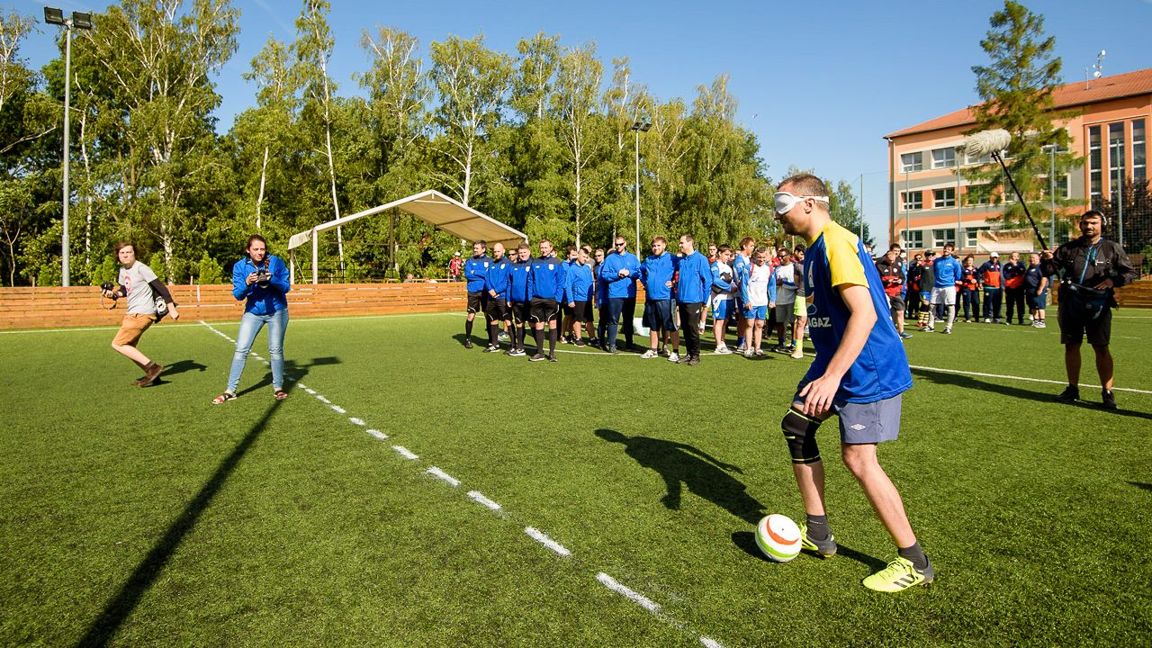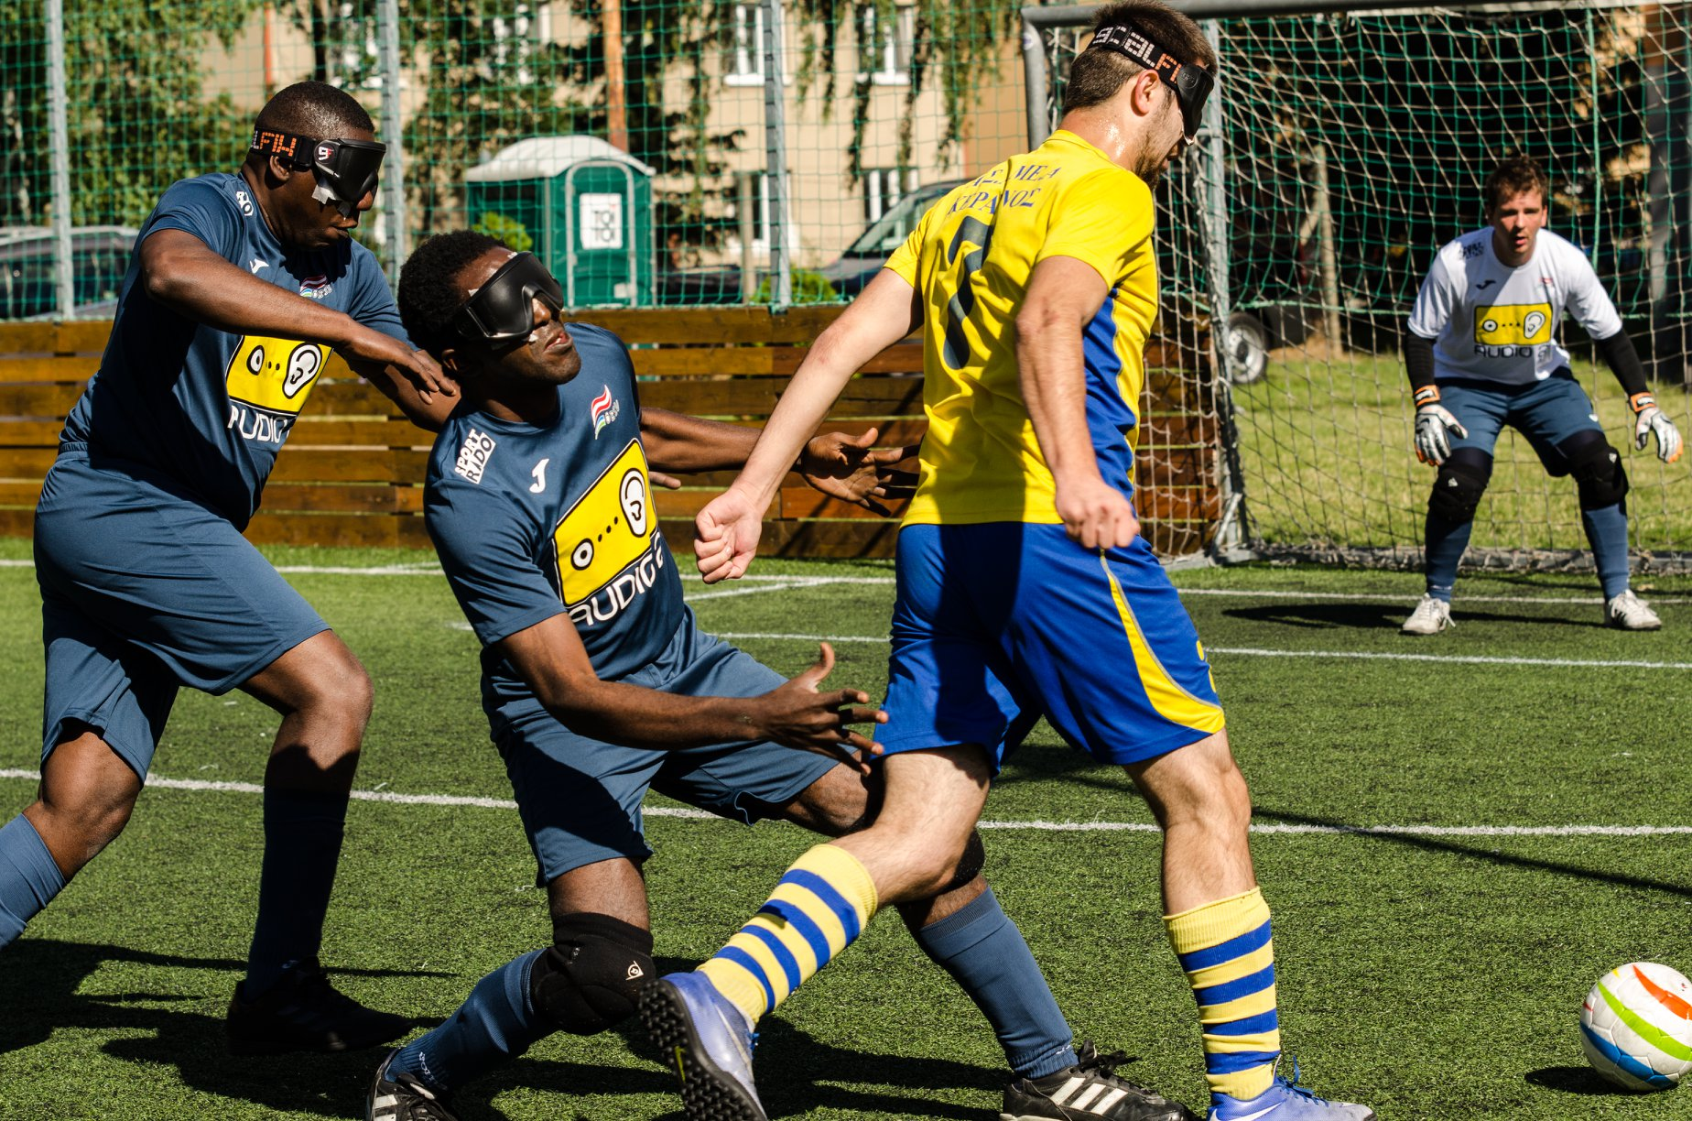
Matěj Plch, the legend of Avoy, and his kick-off Players of Vienna against A. Bezhani from Keravnos
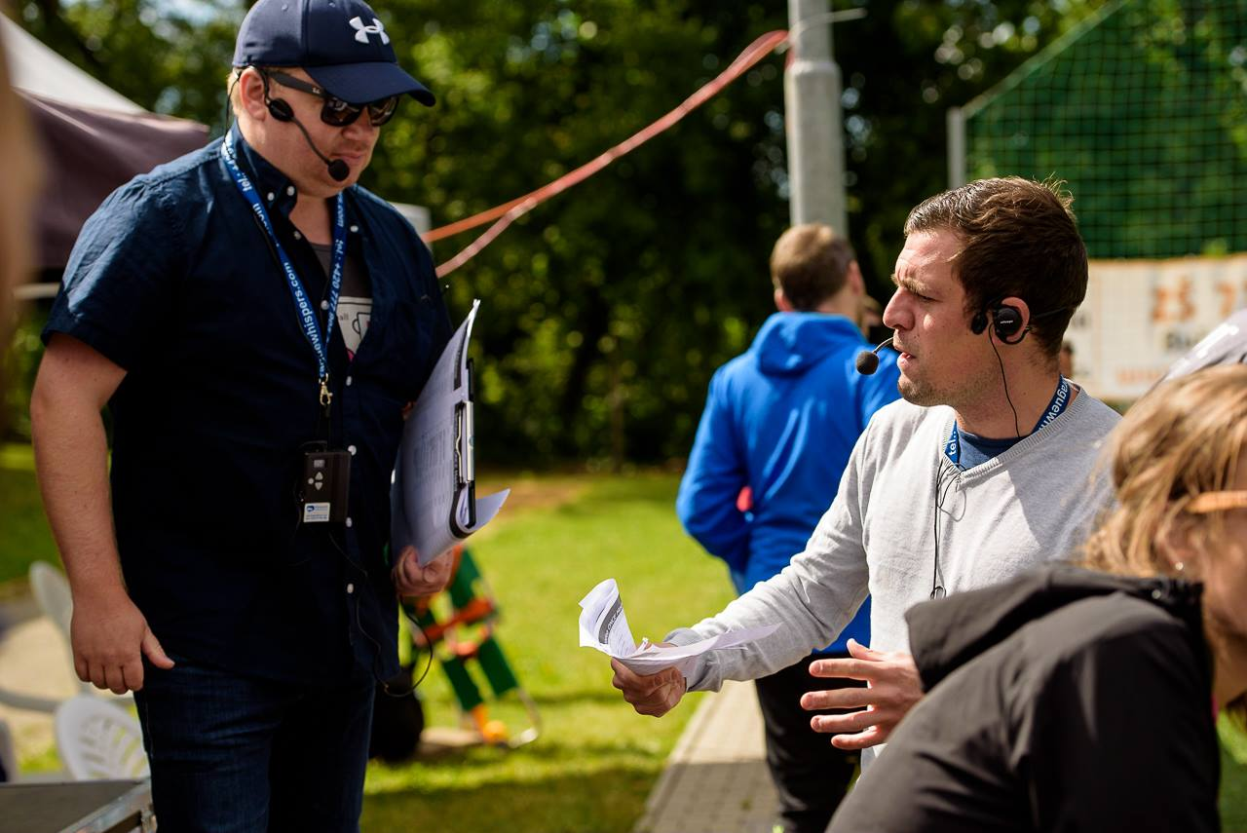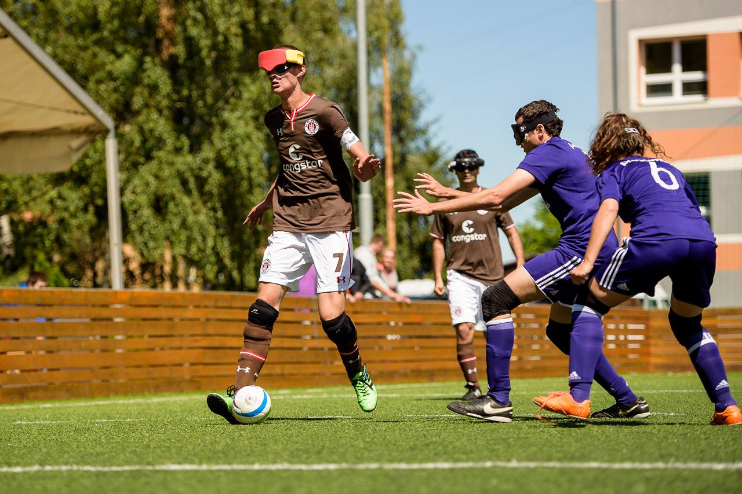
Peter Selby and Maurizio Valgolio, commentators Rasmus Narjes (St. Pauli) against Anderlecht
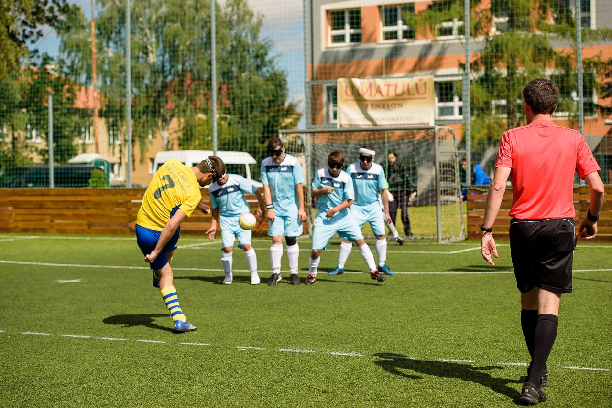 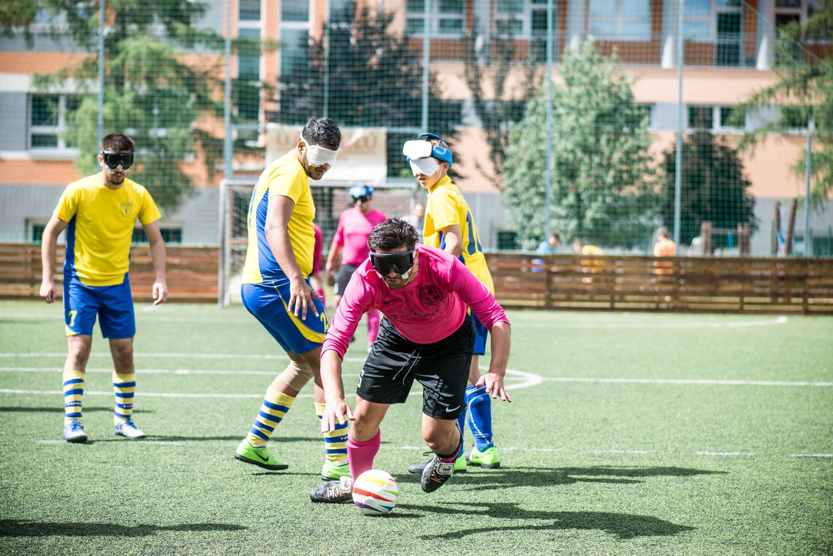¨
Free kick for Keravnos against players of Madrid Keryn Seal (Brno) – the best defender of the tournie

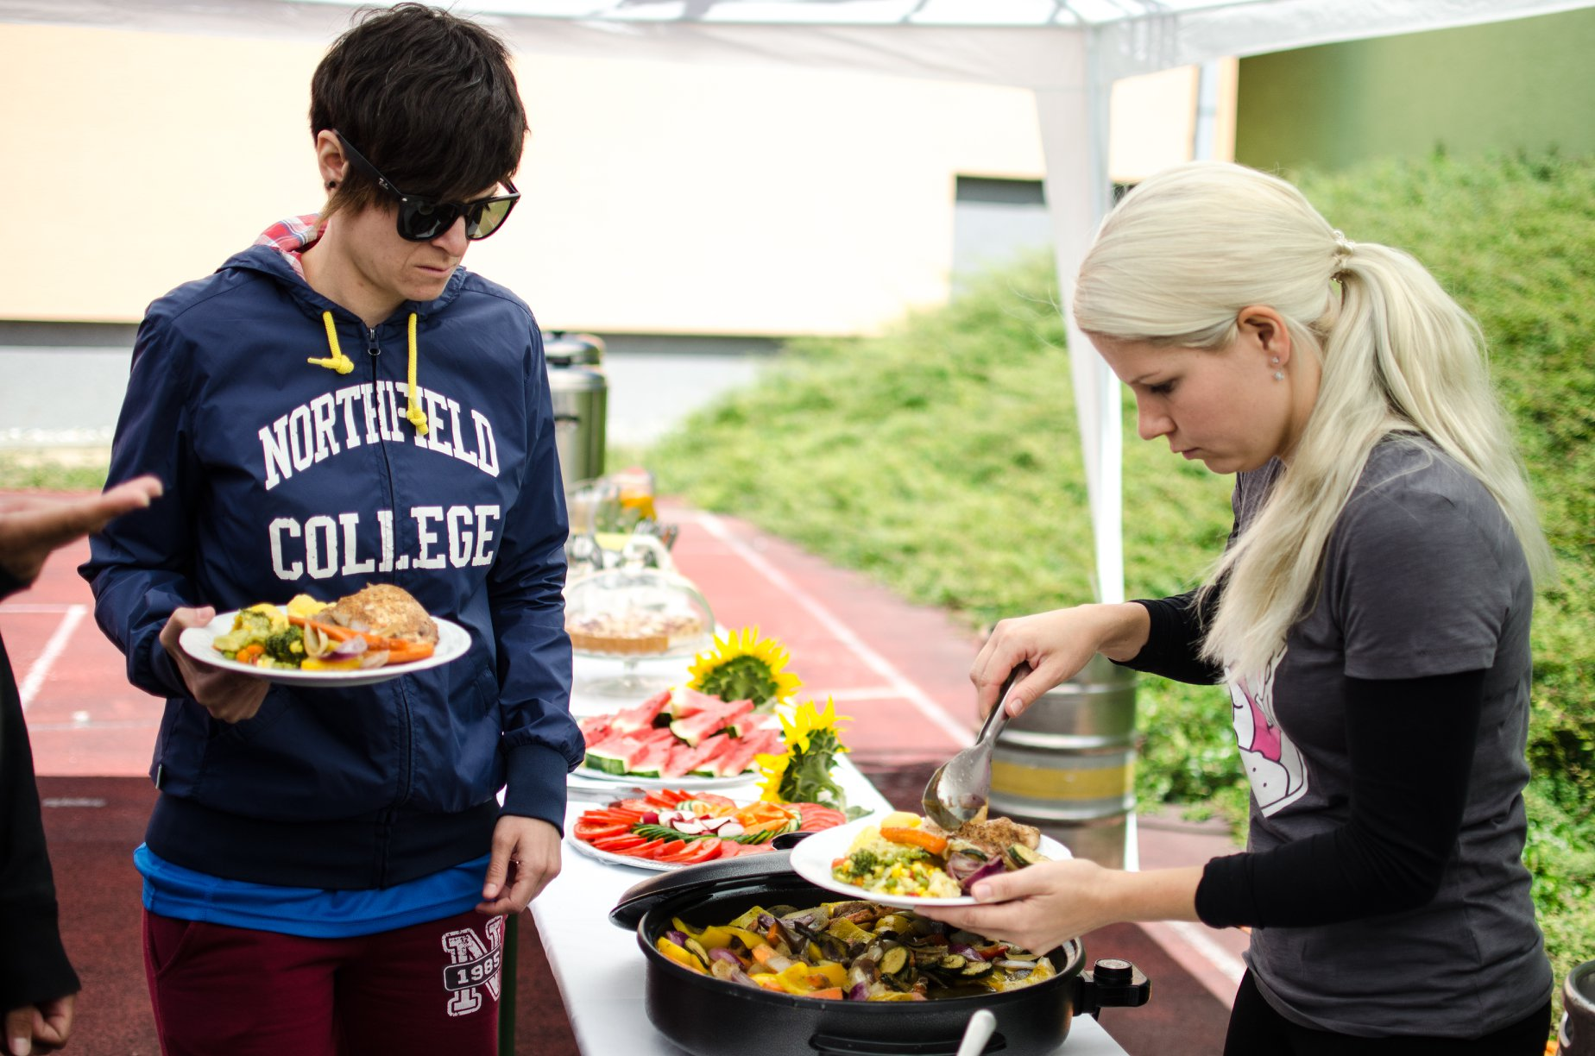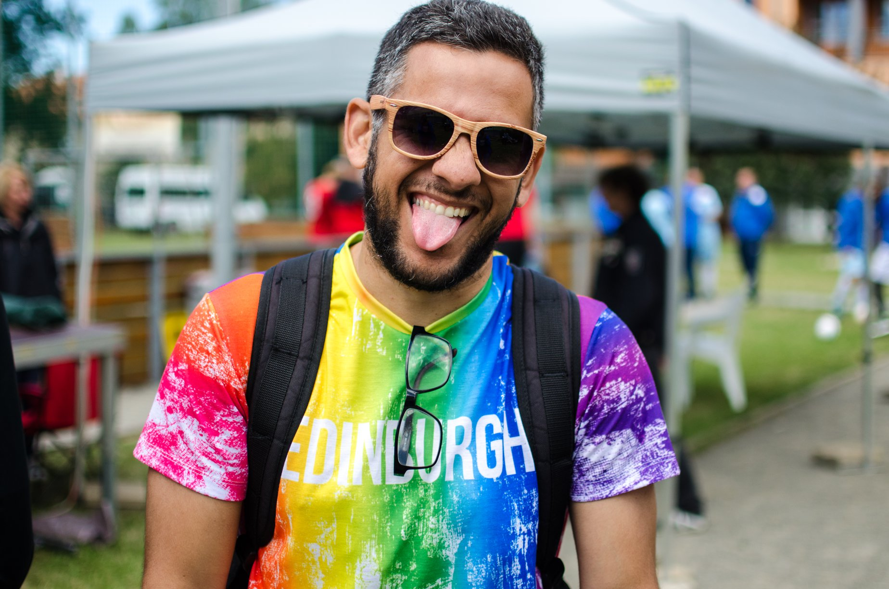
Great catering by Penzion U Matulů Gabriel Mayr from Brazil, Czech blind football pioneer
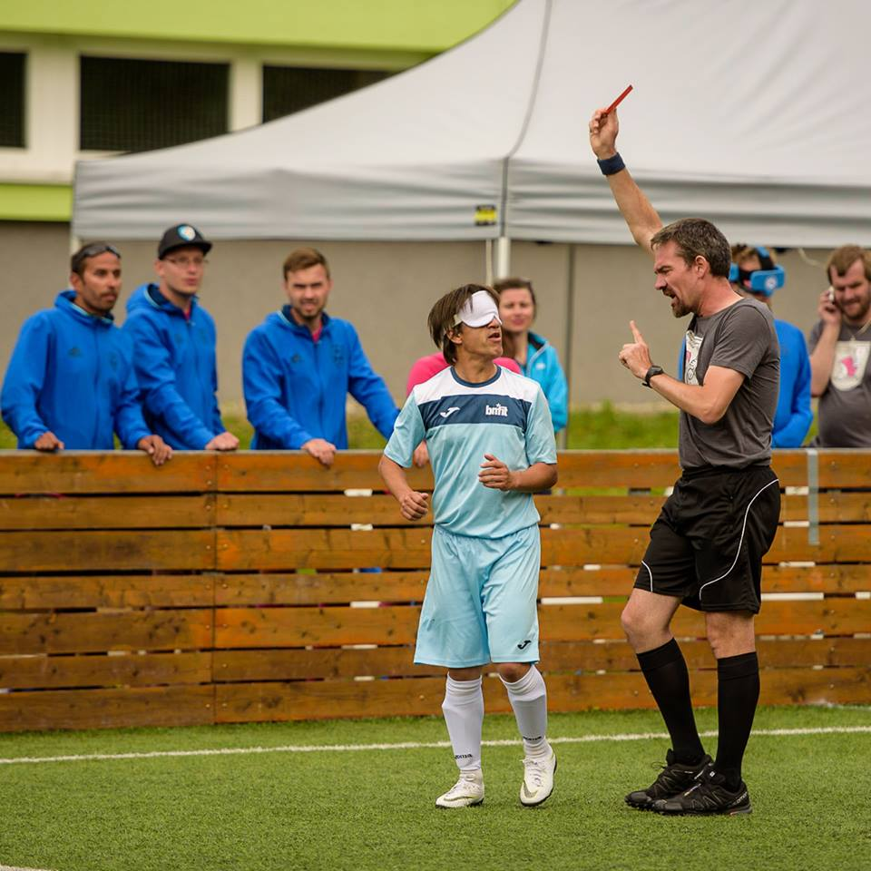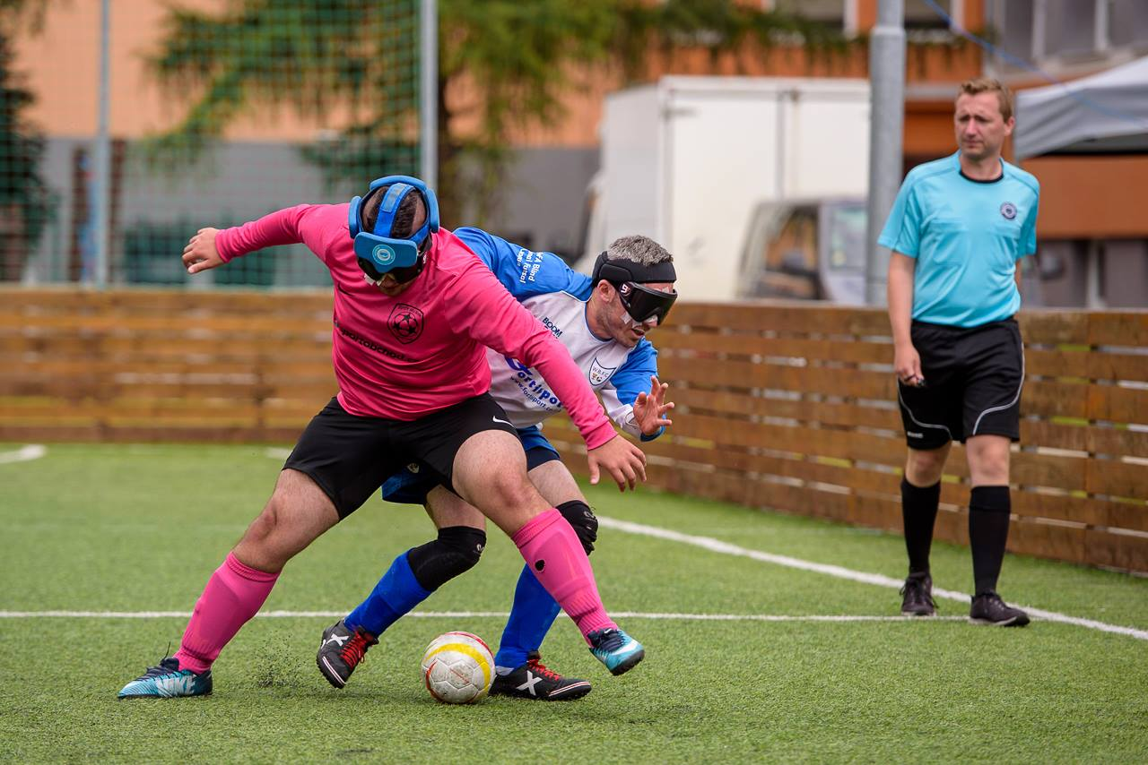
F. Carcouët comitted a red card to V. Aguilar Semifinals, J. Bango against R. Turnham
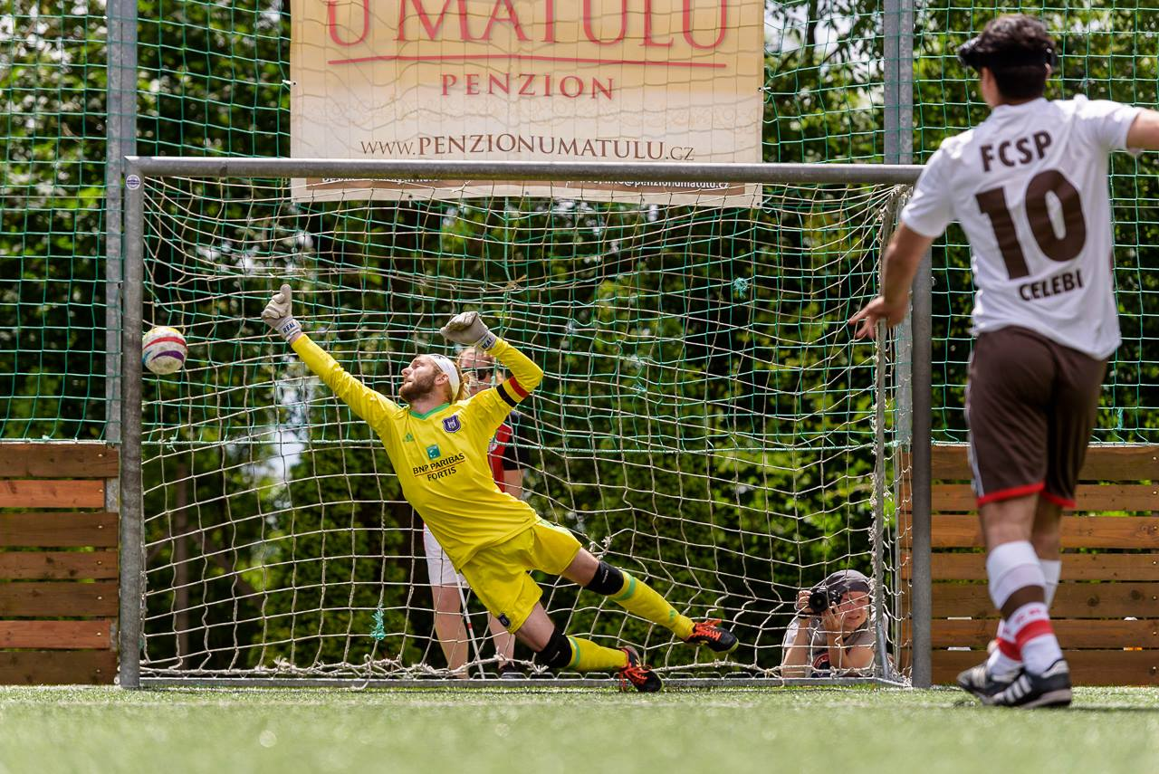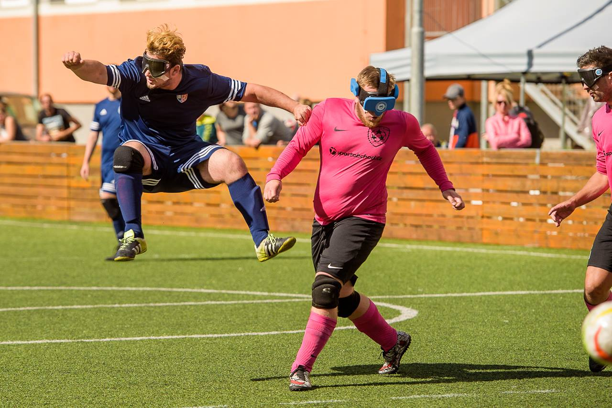
Penalties for the 3rd place of Group B, S. Celebi scored For the 3rd place, R. Mkrtchyan shot the ball
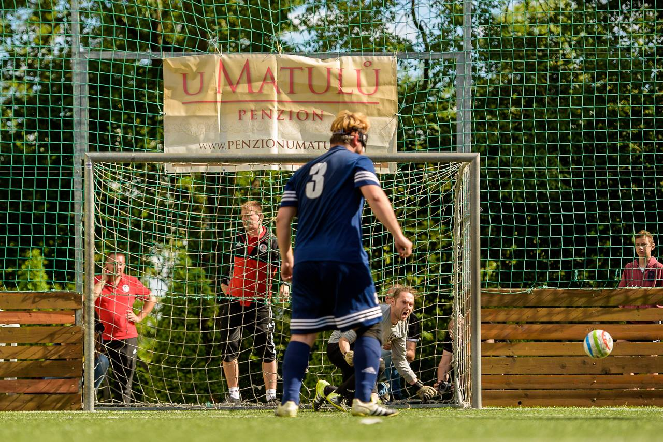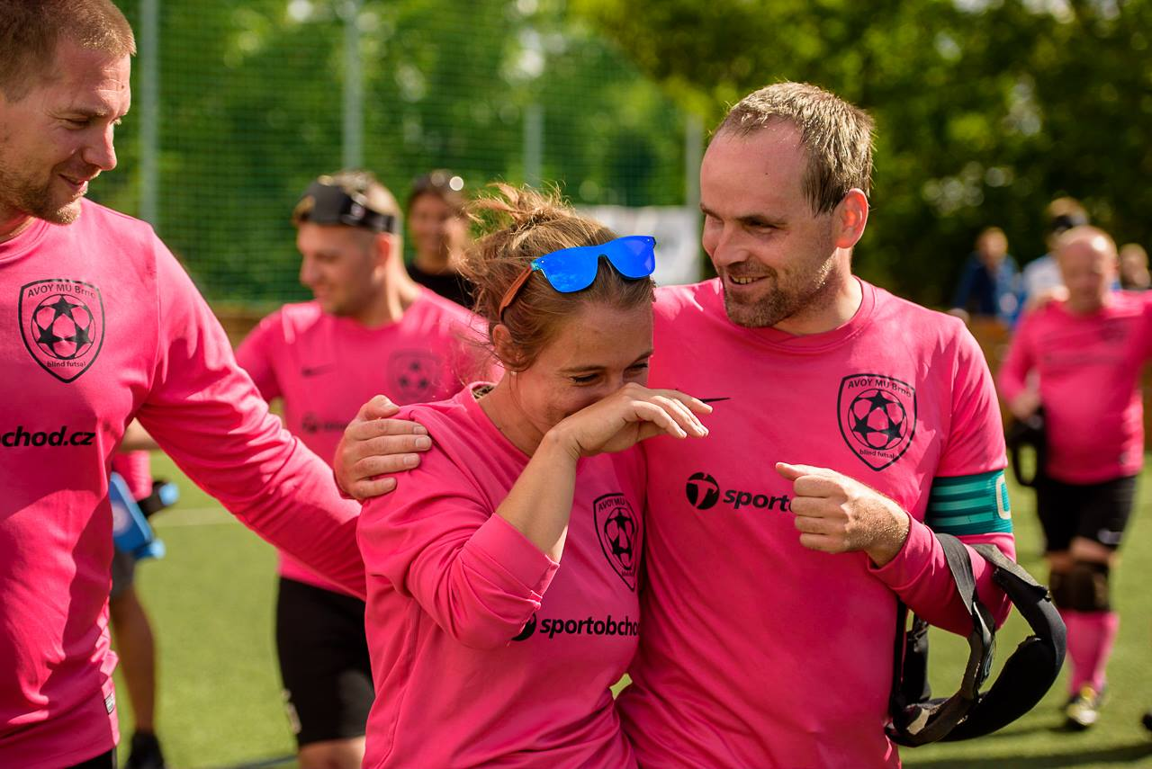
R. Mkrtchyan didn't score, T. Bukovský celebrating J. Graclíková's tears, joy of both shooters of penalties
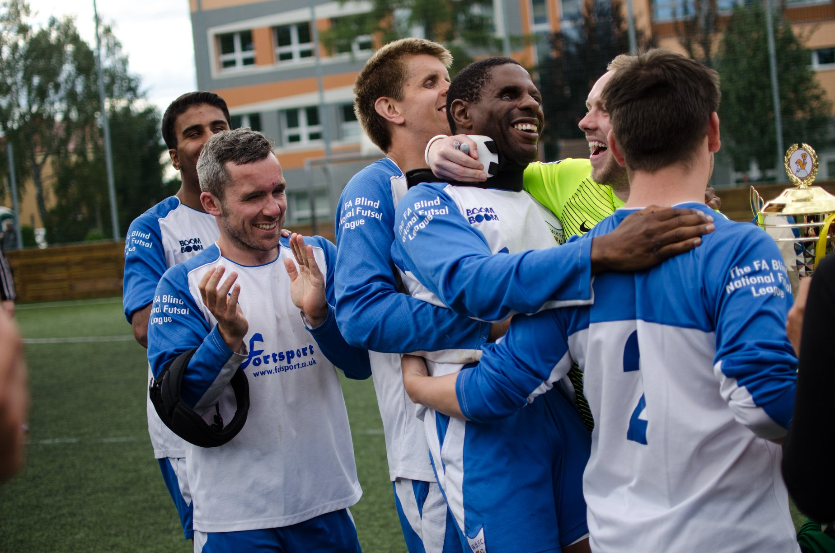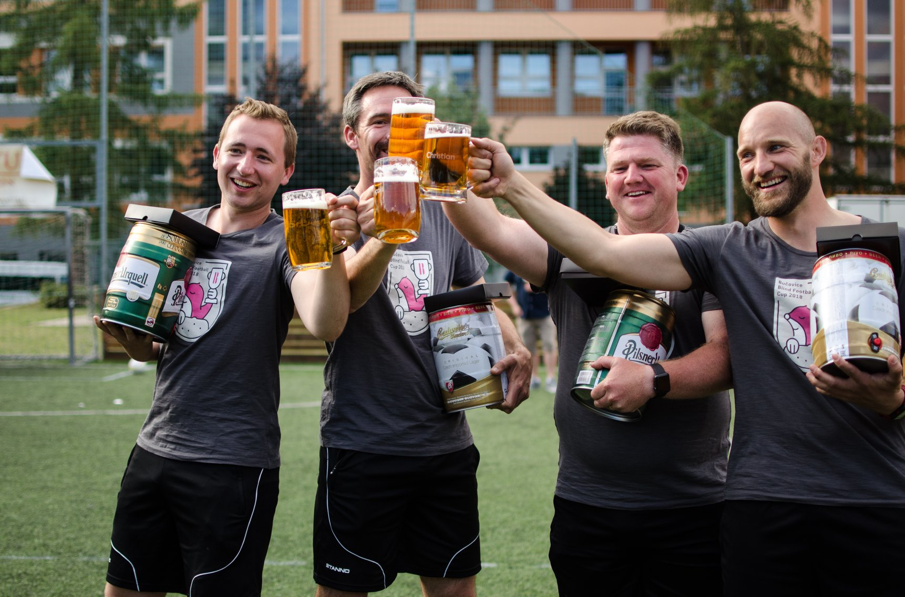
Worcester BFC, winners of the cup Referees during the closing ceremony with their gifts

7. List of partners and sponsors
- Avast Foundation (financial support)
- Seznam.cz (media support)
- Masaryk University (support of any kind)
- Světluška – Nadační fond Českého rozhlasu (financial support)
- Southmoravian Region (financial support)
- Ministry of Education, Youth and Sport, Czech Republic (financial support)
- Football Association of the Czech Republic (financial support)
- Leontinka Foundation (financial support)
- Charta 77 Foundation (financial support)
- Penzion U Matulů (catering)
- ZŠ Školní 710 v Bučovicích (providing the pitch and its surroundings)
- SportObchod.cz (financial and media support)

We thank all the fans, friends, partners and sponsors who help us and support the tournament.

